Sentinel Automatic Antenna Tracker

LITE

User GuIDE

VirtualPilot

NOTICE

The information contained in this document is believed to be accurate in all respects but is not warranted. The information is subject to change without notice and should not be construed in any way as a commitment by the manufacturer, supplier, distributor, affiliates, or subsidiaries.

The manufacturer, supplier, distributor, affiliates, or subsidiaries assume no responsibility or liabilities for any errors or omissions in this document.

Revisions of this document or new editions of it may be issued to incorporate such changes.

No part of this document can be reproduced or transmitted in any form or by any means without written permission from the manufacturer.

This device is a hobby grade device intended for use by hobbyists. It is not intended or warranted for commercial or military use.

This device must only be used in compliance with applicable legislation.

This use of device can be impacted by ferromagnetic / electromagnetic and GPS interference.

**Patents**

Patents pending

**Trademarks**

Other product names mentioned in this document may be trademarks of their respective companies and are hereby acknowledged.

© Copyright 2022, VirtualPilot  
All rights reserved

Table of Contents

Introduction 4

AAT – User Guide supported release 4

AAT – Quick Start guide - wiring 5

AAT – Quick Start guide - configuration 5

AAT – Quick Start guide - using the AAT 6

AAT – GUI 7

AAT – Configuring the AAT 8

AAT – OLED display (optional accessory) 10

AAT – LED status indicators 10

AAT – Updating the firmware 11

AAT – Mounting the VRX / Antenna 12

AAT – Connections and interfaces 13

CRSF/MAVLINK support 14

FC Configuration - iNAV 3.0 onwards (embedded support) 14

FC Configuration - iNAV earlier versions 14

FC Configuration - Ardupilot 14

FC Configuration – Betaflight (unified targets) 15

FC Configuration - Betaflight (older standard targets) 16

Minim OSD configuration (MWOSD) 16

Telemetry module - other FC / OSD 16

AAT – Troubleshooting 17

Sentinel Specifications 19

Sentinel Requirements 19

Document revisions 20

# Introduction

The AAT brings higher quality video and the ability to use lower video transmission power or increase the maximum reception distance over traditional omnidirectional antennas. The AAT provides the benefit of maintaining a more accurate direction over manually mounted antennas without the concern of the aircraft moving outside of the antenna’s dominant reception area.

The AAT is designed to work with many standard Flight Control systems such as iNAV, Ardupilot and Betaflight. The AAT is also designed to work with any systems running MWOSD on standard minim compatible OSD hardware.

The AAT also supports other FC’s that do not have direct support via the use of CRSF / MAVLINK telemetry or via a video modem. A micro minim OSD can be used as a video modem.

This AAT uses a completely new concept for sending aircraft telemetry tracking information without the need of additional hardware on the aircraft and brings simple and easy antenna tracking capability to a wide range of Flight Control systems in use.

The AAT lite version brings a low-cost DIY option to the market using low cost and widely available components. Design files are available for those wanting to develop and improve the design or 3D print their own add-on components.

The AAT lite version provides a full 360-degree pan coverage with a fast end point return.

# AAT – User Guide supported release

* **This manual supports changes for AAT release: 4.0.0**
* **Other releases may have different operation.**
* [**https://github.com/aat-sentinel/Documentation**](https://github.com/aat-sentinel/Documentation)

# AAT – Quick Start guide - wiring

This is intended for users who just want to get going without reading the full manual:

1. **Pin connections are listed in the AAT connections section**
2. **Connect VRX Video, Audio GND and Power to “VRX in” connector on AAT PCB.**
3. **Connect PAN and TILT servos.**
4. **Take special care with connection GND and Power for RX (choice of 5V or full battery voltage)**

# AAT – Quick Start guide - configuration

This is intended for users who just want to get going without reading the full manual:

1. **Power up the AAT and connect to AAT Wi-Fi access point**
2. **Open a web browser and connect to** [**http://192.168.4.1**](http://192.168.4.1)
3. **Using the simulator to test, configure pitch min and max for correct 0 ° and 90** **° tilt operation**
4. **Using the simulator to test, configure yaw range for full 360 ° operation**
5. **Configure voltage scale to display correct voltage value in the GUI**
6. **Adjust cell count and minimum voltage to trigger low voltage warning**
7. **Save settings**
8. **FC - Install a firmware that supports the AAT** [**Click here for files**](https://github.com/aat-sentinel)
9. **FC - Install fonts that support the AAT** [**Click here for files**](https://github.com/aat-sentinel)
10. **FC - Enable AAT telemetry from within the Features menu on the OSD**
11. **Connect RX to AAT**
12. **Power AAT/RX and FC and verify telemetry is received by LED or the web browser**

SENTINEL AAT is 13V maximum supply – a 3S LiPo

# AAT – Quick Start guide - using the AAT

This is intended for users who just want to get going without reading the full manual:

*Initial power up state*: the AAT will center pan and point at an angle slightly above the horizon. The unit can be manually aimed for manual tracking if required. This state will remain until a valid telemetry signal is received.

*FC disarmed state*: when the AAT receives a valid telemetry tracking command, it will point vertically and due North to indicate to the user that the AAT is ready. This state will remain until the FC enters FC armed state.

*FC armed state*: when the aircraft is armed, once the aircraft has moved outside its activation perimeter (10 meters), it will engage and point at the aircraft.

*FC armed state*: if the aircraft moves back within the activation perimeter, the antenna will point vertically.

If enabled, the AAT will provide audible warning for loss of telemetry data or low battery.

Note: The position of the aircraft and it’s tracking is relative to the home position of the aircraft and not the AAT unit itself. AAT should be placed near the set home position.

Note: a power cycle is needed if swapping between NTSC / PAL. It may also be required if the aircraft is powered up after the AAT (verify by the telemetry LED).

To use the AAT:

1. **Power up the aircraft**
2. **Power up the AAT** **(power cycle if telemetry LED is not active)**
3. **Turn the AAT until the antenna points due North**
4. **Verify the AAT is receiving valid data (antenna points vertical and telemetry LED = ON)**
5. **Arm aircraft close to the AAT (with minimum sats needed by the FC)**
6. **Launch aircraft**
7. **Verify antenna is tracking as soon as practical after launch (visual / audible movement)**

Optional - Setting AAT flight direction (if crossover point is in main direction of flight) :

1. **Use mobile phone compass app and point in direction in wish intend to mostly fly**
2. **Set “yaw adjust value” on AAT to be same as compass reading and save settings**
3. **Turn AAT until Antenna points North**
4. **Optional fine adjust manually in flight for perfect accuracy**

SENTINEL AAT is 13V maximum supply – a 3S LiPo

# AAT – GUI

The AAT contains a comprehensive built in GUI for configuring and updating. No additional software is required. Only a PC, tablet or suitable mobile device is required to configure.

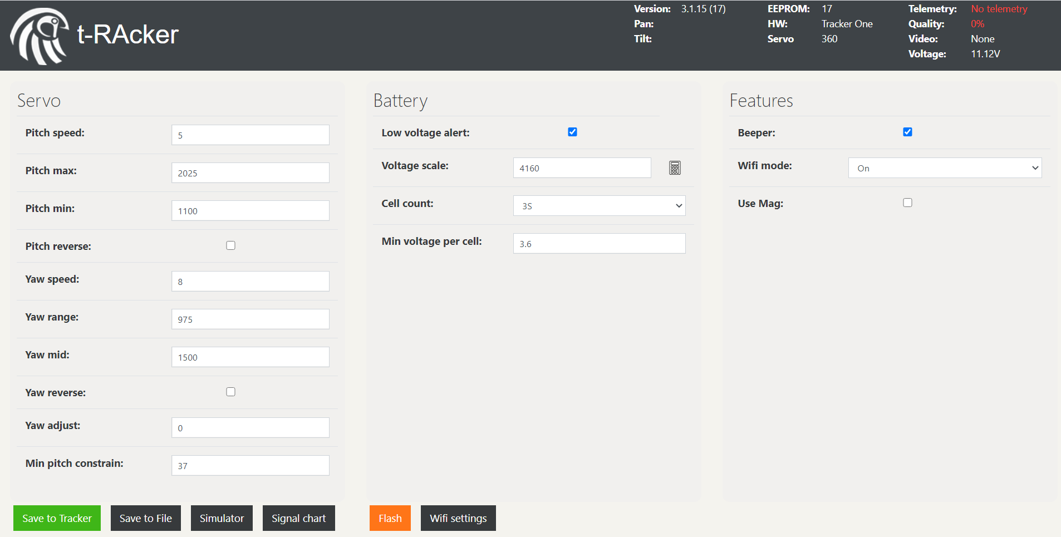

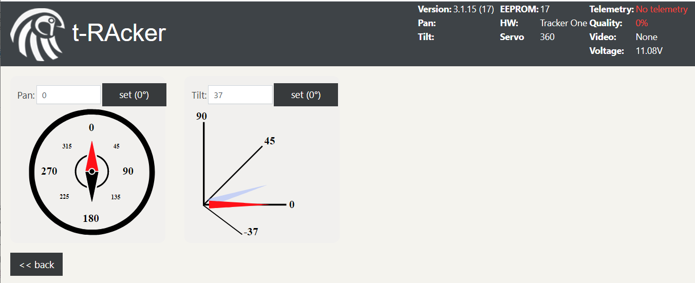

**OTA firmware updates**

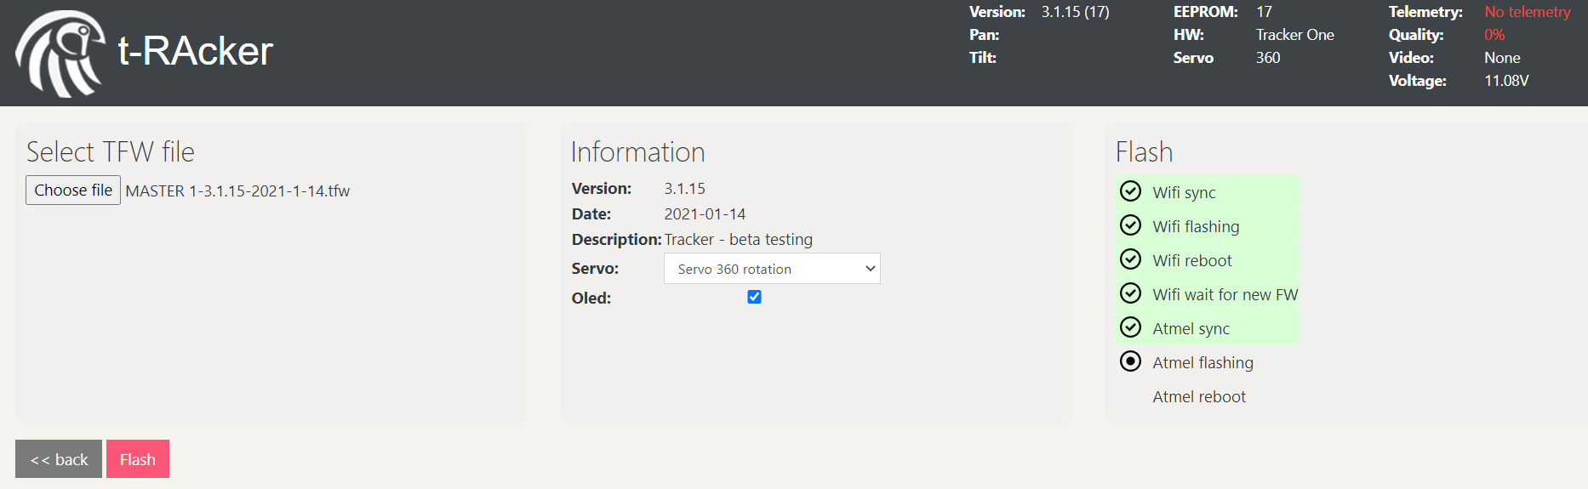

# AAT – Configuring the AAT

The AAT contains a built in Wi-Fi access point and GUI web interface for easy configuration. The Wi-Fi can be disabled when the AAT is in use to avoid interference with any VRX.

To connect to the AAT:

1. **Power up the AAT.**
2. **Open your wireless connections and the AAT should appear shortly.**
3. **Select the AAT wireless network. Allow up to a minute to establish the connection.**
4. **Open a web browser and connect to** [**http://192.168.4.1**](http://192.168.4.1)

To configure the tilt operation (mandatory):

1. **Click on the simulator compass / tilt icon for quick setting of angles.**
2. **Adjust the “Pitch min” so that the antenna is pointing horizontally using the simulator.**
3. **Adjust the “Pitch max” so that the antenna is pointing vertically using the simulator.**
4. **Toggle “Pitch reverse” if pitch travel direction is incorrect.**
5. **Adjust the “Pitch speed” if needed. Recommend using default values to start.**

To configure the pan operation (mandatory):

1. **Click on the simulator compass / tilt icon for quick setting of angles.**
2. **Set “Yaw adjust” to 0.**
3. **Set “Yaw mid” to 1500.**
4. **Adjust the “Yaw range” so that the antenna moves full 360 degrees using the simulator.**
5. **Toggle “Yaw reverse” if travel direction is incorrect.**
6. **Adjust the “Yaw speed” if needed. Recommend using default values to start.**

To configure low battery alarm (recommended):

1. **Adjust the “Voltage scale” so the GUI voltage display matches measured supply voltage.**
2. **Adjust the “Cell count” to match the battery cell count.**
3. **Enable “Low voltage alert” if you desire audible battery low warning.**

To configure loss of tracking alarm (recommended):

1. **Enable “Beeper” if you desire audible loss of tracking signal.**

To configure the AAT Wi-Fi to remove conflict with VRX (recommended for 2.4 VRX):

1. **Set “Wi-Fi” mode to “Auto disable” to reduce 2.4G interference to your VRX when in flight.**

To configure the AAT to use negative elevations (not typically required):

1. **Adjust the “Min pitch constrain” if needed.**
2. **A value of 37 equates to 0° or horizon (default)**
3. **A value of 0 equates to tracking at -37° below the horizon**
4. **The AAT will need to be able to physically support this without mechanical interference**

To configure AAT Wi-Fi settings (optional)

1. **If flying with others using the same AAT, change SSID from defaults.**
2. **Enable authentication and passphrase to prevent malicious connections**
3. **Changes will require reconnection and / or a password into your connecting device**
4. **ONLY use alphanumeric characters – others may not be supported**

Recommended initial settings

|  |  |
| --- | --- |
| **Pitch speed** | 5 |
| **Pitch max** | 2025 |
| **Pitch min** | 1100 |
| **Pitch reverse** | unticked |
| **Yaw speed** | 8 |
| **Yaw range** | 975 |
| **Yaw mid** | 1500 |
| **Yaw reverse** | unticked |
| **Yaw adjust** | 0 |
| **Min pitch constrain** | 37 |
| **Low voltage alert** | ticked |
| **Voltage scale** | 4160 |
| **Cell count** | 3S |
| **Min voltage per cell** | 3.6 |
| **Beeper** | ticked |
| **Wifi mode** | on |
| **Use Mag** | unticked |

# AAT – OLED display (optional accessory)

Voltage operation showing:

* Battery voltage
* Signal strength
* Uncorrected Magnetic angle
* Analog or Mavlink status

Normal operation showing:

* Battery voltage
* Tilt angle
* Pan angle
* Signal strength
* Uncorrected Magnetic angle

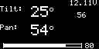

Example No signal and error message displays:

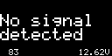   

# AAT – LED status indicators

|  |  |  |
| --- | --- | --- |
| Indicator | Recommended color | Action |
| Power | Green | ON = Unit is receiving power |
| Telemetry | Blue | ON = Telemetry is being captured from the video signal |
| Status | Red | ON / FLASHING indicates a warning – e.g. loss of telemetry / battery low |
| WiFi | Orange | ON = WiFi enabled |

# AAT – Updating the firmware

1. **Download the latest AAT firmware from** [**here**](https://github.com/aat-sentinel/AAT-lite-firmware)**.**
2. **Power up the AAT.**
3. **Open your wireless connections and the AAT should appear shortly in the networks list.**
4. **Disconnect from existing network first to prevent auto reconnect.**
5. **Select the AAT wireless network. Allow up to a minute to establish the connection.**
6. **Open a web browser and connect to** [**http://192.168.4.1**](http://192.168.4.1)
7. **Take note / screenshot of existing settings**
8. **Select the “Flash” icon.**
9. **Choose the TFW file**
10. **Select the appropriate variant (lite = Standard servo / 360 rotation)**
11. **Select OLED if you have an OLED display fitted**
12. **Select the red “Flash” button**
13. **When flashing completed, allow time for the AAT to restart and the GUI to connect**
14. **After re-connecting:** 
    1. **Force a browser refresh to see updated GUI (“CTRL” and “F5” simultaneously on a PC).**
    2. **verify the version number displayed is correct.**

**WARNING:** do not disconnect WiFi or Power during flashing. This may render the AAT inoperable.

**NOTE**: The AAT typically takes 60 seconds during the flashing process. If the tracker takes longer, it may have locked up. Usually a power cycle, reconnect and reflash will complete the upgrade process.

**NOTE:** for some version updates, all AAT configuration information will be reset to default. The AAT will need to be re-configured and re-calibrated. This may include the Wi-Fi SSID settings which means the Wi-Fi connection may have to be re-selected.

**NOTE:** turn off any VTX which might be transmitting with AAT telemetry enabled as it may auto-disable the AAT.

**TIP:** Double check another device is not auto connecting to the AAT during the update as this can affect the update process. Enabling auto connect on PC can help avoid this.

# AAT – Mounting the VRX / Antenna

3D STL and Google Sketchup files are available for printing mounting options.

These currently include files for:

* Eachine Pro 58 diversity RX,
* AKK 5.8 diversity RX
* IRC Uno.

These can be easily modified for other RX units.

The Tilt plate has mounting points 80mm apart for any user created mounting brackets.

Care should be taken to minimise stress on the AAT by reducing antenna / VRX weight and ensuring both are placed as close to the AAT mounting plate as possible.

The recommended maximum weight should not be exceeded.

* **Download the latest 3D STL files from** [**here**](https://github.com/aat-sentinel/AAT-lite-hardware)**.**
* **User contributed 3D STL files are available** [**here**](https://github.com/aat-sentinel/User-creations-STLs-)**.**

# AAT – Connections and interfaces

### AAT – Connecting

1. **All DC sockets are joined together.**
2. **Internal VRX connector in for AV and supports 5v or V battery supplies for the RX. Choose VRX supply carefully!**
3. **Dual independent outputs - one Fatshark compatible and one standard RCA video.**
4. **Note: audio pins 1 and 2 are linked together internally**
5. **Note: external power output for RX is connected directly to battery input (V battery)**

### AAT – LED indicators

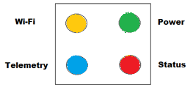

### AAT – AV connector pinout

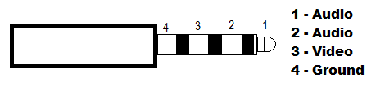

### AAT – DC Battery power connector polarity



# CRSF/MAVLINK support

Sentinel also supports antenna tracking using CRSF/MAVLINK data - the following link contains the documentation to assist in using Mavlink/CRSF instead of video telemetry.

**Mavlink configuration:** [**https://github.com/aat-sentinel/Documentation**](https://github.com/aat-sentinel/Documentation)

# FC Configuration - iNAV 3.0 onwards (embedded support)

1. **Use CRSF/MAVLINK – or:**
2. **Flash iNav**
3. **Ensure iNav font updated**
4. **Enable AAT telemetry in the cli:** **set osd_telemetry = ON**
5. **WARNING: this is not currently compatible with SAFEHOME. Do not use SAFEHOME**

# FC Configuration - iNAV earlier versions

1. **Use CRSF/MAVLINK – or:**
2. **Download AAT enabled firmware to your PC**
3. **Flash iNav with AAT enabled firmware. (Firmware Flasher > Load Firmware [Local])**
4. **Download required AAT enabled font to your PC**
5. **Update Font (OSD tab>Font Manger>Open Font File>Open downloaded font>Upload Font**
6. **Enable AAT telemetry in the cli: set osd_telemetry = ON**
7. **WARNING: this is not currently compatible with SAFEHOME. Do not use SAFEHOME**

# FC Configuration - Ardupilot

1. **Use CRSF/MAVLINK – or:**
2. **Requires minim compatible hardware OSD**
3. **Install MWOSD on the OSD hardware**
4. **Follow instructions for MWOSD – configuration**

# FC Configuration – Betaflight (unified targets)

1. **Use CRSF/MAVLINK – or:**
2. **Backup / dump diff CLI contents of your existing board into a file for safety / reference**
3. **Determine which board / Betaflight target you use. e.g. IFRC-IFLIGHT_F405_TWING**
   1. **Open the config file for your board from link:**
      * [**https://github.com/aat-sentinel/FC-Betaflight**](https://github.com/aat-sentinel/FC-Betaflight)
   2. **Identify the unified target from within the config file - It will be the second word in the file :**
   3. **e.g. IFRC-IFLIGHT_F405_TWING unified target is STM32H743**
4. **Flash the unified target**
   1. **Download the correct hex and config files for your board so they can be loaded locally from** 
      * [**https://github.com/aat-sentinel/FC-Betaflight**](https://github.com/aat-sentinel/FC-Betaflight)
   2. **Select Load Firmware [local]**
   3. **Browse and select the *.config file for your board and OK**
   4. **Browse and select the *.hex file for your board and OK**
   5. **Select Flash Firmware**
5. **Configure FC settings**
   1. **Connect with Betaflight GUI configurator**
   2. **Configure settings as needed**
   3. **Enter CLI and copy / paste the settings you require**
   4. **in the cli: set osd_telemetry = ON**
   5. **Save / reboot**
   6. **Your FC is now updated and ready**
6. **Update Font**
   1. **Download the correct version font files so they can be loaded locally from** 
      * [**https://github.com/aat-sentinel/FC-Betaflight**](https://github.com/aat-sentinel/FC-Betaflight)
   2. **Upload font (OSD tab>Font Manger>Open Font File>Open downloaded font>Upload Font)**

# FC Configuration - Betaflight (older standard targets)

1. **Use CRSF/MAVLINK – or:**
2. **Download AAT enabled firmware to your PC**
3. **Flash iNav with AAT enabled firmware. (Firmware Flasher > Load Firmware [Local])**
4. **Download required AAT enabled font to your PC**
5. **Update Font (OSD tab>Font Manger>Open Font File>Open downloaded font>Upload Font**
6. **Enable AAT telemetry in the cli: set osd_telemetry = ON**

# Minim OSD configuration (MWOSD)

1. **Use CRSF/MAVLINK – or:**
2. **Flash MWOSD with AAT enabled firmware. Release 2.0 onwards**
3. **Enable AAT in MWOSD GUI configurator “other” tab**
4. **Ensure a 2.0 onwards font is used**

# Telemetry module - other FC / OSD

1. **Use CRSF/MAVLINK – or:**
2. **Instructions :** [**https://github.com/ShikOfTheRa/scarab-osd/wiki/Video-telemetry-module**](https://github.com/ShikOfTheRa/scarab-osd/wiki/Video-telemetry-module)

# AAT – Troubleshooting

First, please read the Quick Start configuration guide steps to make sure no steps have been missed.

### AAT – Troubleshooting #1 – No tracking Telemetry

1. **Ensure the FC has AAT enabled firmware installed.**
2. **Ensure Telemetry is enabled in FC.**
3. **Ensure AAT enabled fonts have been uploaded to the FC.**
4. **Ensure RX is powered up and connected correctly. Video visible on outputs.**
5. **Note: Telemetry sending will not be active in OSD menu or statistics pages.**
6. **Set osd_telemetry = TEST on supporting FC’s will show a test telemetry line for verification.**
7. **Power cycle AAT after aircraft has been powered up. Some cameras have unusual startup.**

### AAT – Troubleshooting #2 – Unable to connect to GUI

1. **Ensure the AAT is showing in the networks list and is the connected network.**
2. **Only one AAT connection at a time is permitted – verify mobile devices are not connected.**
3. **If Auto-disable is selected (default), the AAT Wi-Fi is disabled when the aircraft is receiving telemetry.**

### AAT – Troubleshooting #3 – AAT not pointing directly at aircraft

1. **Ensure the aircraft is armed close to the AAT otherwise accuracy improves at range.**
2. **Ensure when disarmed the antenna points to true North. This is reference point**
3. **WARNING: this is not compatible with iNav SAFEHOME. Do not use SAFEHOME**

### AAT – Troubleshooting #4 – WiFi login / password issues

1. **From release 3.2.3, configuration settings may be changed by powering up the AAT and putting a jumper on W-BOOT pins for 10 seconds. Onboard ESP module LED will flash briefly.**
2. **Note – for this to work, jumper must be put on ONLY after the PCB had been powered up.**
3. **Note – this will reset all AAT settings.**

### AAT – Troubleshooting #5 – Dual camera support

1. **DUAL camera configurations are supported, however both cameras must be using the same video format – either both NTSC or both PAL.**

### AAT – Troubleshooting #6 – Problems flashing firmware

1. **Power cycle / restart PC**
2. **Power cycle / restart AAT**
3. **Make sure only one PC is connected to AAT. Check mobile devices do not autoconnect.**
4. **Make sure RC TX is off to avoid Interference. Also it may connect to Tracker Access Point**
5. **Make sure VTX is off to avoid interference.**
6. **Make sure only one browser window is open.**
7. **Make sure only one tab is open on the browser and used to connect to the AAT.**
8. **Make sure PC programming from is set to connect to AAT with autoconnect.**
9. **Between failed programming attempts, power cycle AAT and ensure PC reconnects.**
10. **Other local AP are better to have autoconnect removed during programming.**

# Sentinel Specifications

|  |  |
| --- | --- |
| Input Voltage – DC jack | Recommend 3S LiPo. Operational Voltage 7v-13v |
| Output Voltage – DC jack | Same as input voltage |
| Output – RX PCB 5v | 5v / 3A |
| Output – RX PCB Vcc | Same as input voltage |
| Voltage connectors | 2.1mm x 5.5mm DC barrel jack |
| Video input connectors | 0.1” PCB pin header (internal) |
| Video output connectors | 1 * 4 Pole 3.5mm Fatshark / IRC compatible pinout  1 * RCA phone. Video |
| Load Capacity | 1KG |
| Angular variance | Typically, +/-2 degrees when correctly calibrated |
| Antenna recommendation | Antennas with a beamwidth @ -3db of > 10 degrees. |
| Tripod mount | Recommended:  HAMA STAR 63 (166cm / good value)  HAMA STAR 64 (185cm)  ZOMEI Q111 (134cm – very good value / lower height) |

# Sentinel Requirements

|  |  |
| --- | --- |
| Configuration | A PC / mobile device with Wi-Fi connectivity and browser to access and configure the unit. Windows / IOS / Android. |

TIP: when windy, use weight to stabilise your tripod. Many tripods have hooks to facilitate.

# Document revisions

|  |  |
| --- | --- |
| 1.0 | Initial release |
| 1.1 | Updates |
| 1.2 | Updates |
| 1.3 | Added note re WiFi characters  Added pan/tilt  Reset settings |
| 1.4 | Corrected LED image  Added recommended LED colors and LED description.  Added disconnect recommendation--  Added PAL/NTSC power up restart notes  Added DUAL Camera support note |
| 1.5 | Improved description of setting flying direction |
| 1.6 | Updated Betaflight instructions |
| 1.7 | Added RX supply spec  Added flash troubleshooting  Added Mavlink |